Help us give you the best care
- Be honest about your medical history and the way you live. Don’t leave anything out when telling your medical history. The little things that you don’t tell us may affect your pregnancy and your baby’s health.
- Ask questions when you don’t understand
- Follow the advice given by the staff. Let us know if you might not be able to follow the advice for some reason.
- Let us know if there is a change in your health.
Remember:
- Come to all of your appointments
- Be on time
- Call us if you are going to be late
- Call 24 hours in advance if you need to cancel an appointment
- Tell us if you change your address or phone number
- Let us know if you have any ideas about making our services better
Important Numbers:
Our office phone number:
When we are closed, call:
Name of family members or friends who can assist you in an emergency:
Name:
Home phone:
Mobile:
Work:
Name:
Home phone:
Mobile:
Work: ________________________________
Emergency Hospital
Address:
Cross Street:
Phone:
Delivery Hospital
(If different from Emergency Hospital)
Address:
Cross Street:
Phone:
Childbirth Preparation Classes
Address:
Cross Street:
Phone:
WIC (Women, Infant, Children Program)
Address:
Cross Street:
Phone:
Breastfeeding Help
Address:
Cross Street:
Phone:
Dentist
Address:
Cross Street:
Phone:
Community Agencies
Local resources:

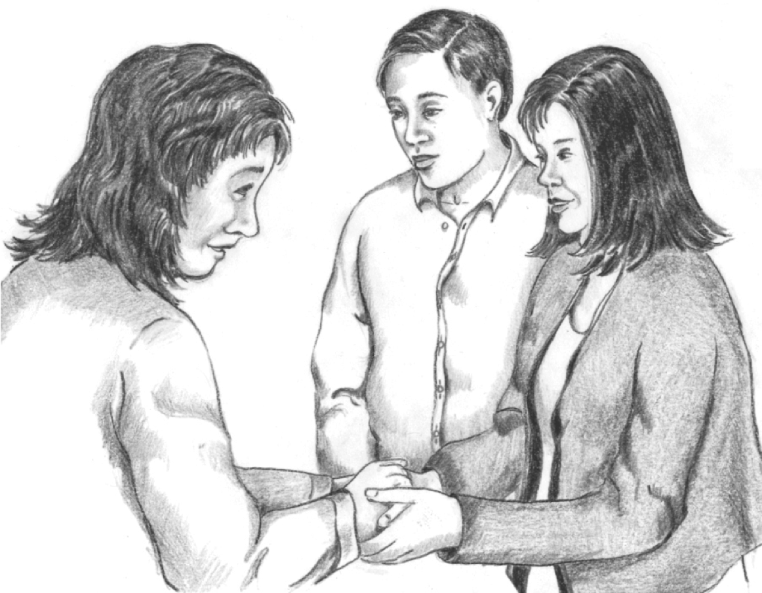

Welcome to Pregnancy
Care
We are here to help!
There are many kinds of people who may help you during your pregnancy: doctors, nurse midwives, nurses, health educators, community health workers, social workers, nutritionists, job counselors, Medi-Cal workers, and family planning counselors.

Our clinic name, address, and phone:

We have many services
We can work together to keep you and your baby healthy.
The services we offer:
- Check-ups once a month or more, the whole time you are pregnant
- Tests to check your health and the health of your baby
- Classes and one-on-one information about pregnancy, childbirth, baby care, and breastfeeding
- A tour of the hospital where you will have your baby
- Referral to community agencies that can provide additional help and services
- Information about where to go for financial help, health insurance like Medi-Cal or Healthy Families, food programs like WIC or food banks
- Help with cutting down or quitting smoking, drinking, or using drugs
- Help eating healthy foods while you are pregnant
- Counseling on problems or family issues you may have

On our staff, here are some of the people who may be helping you:

Client Rights
We promise to:
- Treat you with respect
- Make sure that what you say to us stays private
  - We will keep your medical information private
  - We will not give your medical information to anyone else unless you give us permission in writing
  - However, you should know that the law says we must report abuse or violence so that you can get extra help. If we do need to report, we will call the agency that can best help you.
- Explain any tests you will need and how we do things at this office
- Answer questions you might have about your baby and your care
You have the right to:
- Look at your medical record with someone from our office
- Help plan and make choices about your care while you are pregnant, in labor, or giving birth
- Accept or refuse any care, treatment, or service

Danger or Warning Signs
Call us right away if:
- You feel dizzy
- You have a fever or chills
- You have a really bad headache, or your headache goes on for days
- You have any changes in your eyesight such as: blurred vision, flashes of lights, halos, or spots in front of your eyes
- Your face or hands swell
- It is hard to breathe
- You fall, suffer a blow to the stomach, or are in a car accident
- You vomit or have a bad stomach ache
- You gain too much weight too quickly
Don’t wait! Call right away if you:
- Have any bleeding from your vagina
- Have a sudden flow of water or if water leaks from your vagina
- Feel a big change in the way your baby moves, or if your baby moves less often
- Have a sharp pain when you urinate (pee)
Later in your pregnancy, call us right away, day or night, if you have:
- Stomach ache or cramps (with or without diarrhea)
- Contractions - Your uterus tightens 5 or more times in 1 hour
- Pain or pressure in your belly, thighs, or around your vagina, as if the baby is pushing down
- Change in the discharge from your vagina –
- there may be more mucus, or the discharge may be bloody or watery
- Lower backache - pain or dull pressure in your back, or back pains that come and go in a regular pattern

